**INTEGRATING ANIMAL AVOIDANCE**

**MECHANISMS SYSTEM**

## A MINI PROJECT REPORT

***Submitted by***

|  |  |
| --- | --- |
| **AJAY KUMAR** | **(730921106003)** |
| **AMAN** | **(730921106004)** |
| **ANJALI KUMARI** | **(730921106009)** |
| **KUNAL RAJ** | **(730921106053)** |

*In fulfilment for the award of the degree*

*of*

**BACHELOR OF ENGINEERING**

**in**

**ELECTRONICS AND COMMUNICATION**

**ENGINEERING**

**EXCEL ENGINEERING COLLEGE (AUTONOMOUS)**

**Komarapalayam-637303**

**MAY-2024**

# EXCEL ENGINEERING COLLEGE (AUTONOMOUS) KOMARAPALAYAM

## BONAFIDE CERTIFICATE

Certified that this Project report **“INTEGRATING ANIMAL AVOIDANCE MECHANISM SYSTEM”** isthe work of **AJAY KUMAR (730921106002), AMAN (730921106003), ANJALI KUMARI (730921106009)** and **KUNAL RAJ (730921106053),** who carried out the project work under my supervision.

**SIGNATURE OF THE HOD SIGNATURE OF THE SUPERVISOR**

Dr. S . ANBU KARUPPUSAMY, Mr. P. LOGANATHAN, M.E.,

M.E., Ph .D.,

Head of Department of ECE Assistant Professor

Excel Engineering College Department of ECE

Komarapalayam – 637303 Komarapalayam – 637303

Submitted to the Mini Project Examination Held On……………………………

**INTERNAL EXAMINER EXTERNAL EXAMINER**

# ACKNOWLEDGEMENT

It is with great pride that we express our gratitude in-depth to our institution **EXCEL ENGINEERING COLLEGE** for providing us the opportunity to do the project.

We are greatly indebted to our Chairman **Dr. A. K. NATESAN, M.Com., MBA (NIT)., M.Phil., Ph.D., FTA.,** and **Dr. N. MATHAN KARTHICK, M.B.B.S., M.H.Sc.(Diabetology)., AKF.,** Vice Chairman of **EXCEL GROUP OF INSTITUTION** for providing all the facilities for successfully completing the project.

We express our heartly thanks to Principal **Dr. K. BOMMANNA RAJA, M.E., Ph.D.,** for his valuable suggestion in our entire endeavor.

We sincerely thank our respected Administration Director of EEC **Dr. S. ANBU KARUPPUSAMY, M.E., Ph.D.,** and Academic director of EEC **Dr. C. KARTHIKEYINI M.E, Ph.D.,** for approving this project and granting permission to do in and around Excel Institution.

We thank the Head of the Department **Dr. S. ANBU KARUPPUSAMY, M.E., Ph.D.,** of Electronics and Communication Engineering for his guidance and constant inspiration and we express our gratitude to our Coordinator **Mr. N. RAJAGOPALA KRISHNAN, M.E.,** for their encouragement.

We wish to express our Heartfelt Thanks and sincere acknowledgment to our guide **Mr. P. LOGANATHAN, M.E.,** for his encouragement and dedicated guidance.

We take the privilege to record our everlasting and loving thanks to our parents for their kind help and support which render in bringing our Project fruitful manner.

# ABSTRACT

We introduce a novel approach to mitigating wildlife intrusion in agricultural fields through the integration of an Animal Avoidance Mechanism System (AAMS) comprising Light Dependent Resistor (LDR), Laser Alert System, Sound, and SMS Alert technologies. The system is designed to safeguard crops and prevent damage caused by wildlife such as deer, rabbits, and birds. The AAMS utilizes LDR sensors strategically placed across the agricultural field to detect changes in ambient light indicative of animal presence. Upon detection, the system activates a laser alert mechanism, emitting visible signals to deter wildlife from entering the protected area. Additionally, an audible sound alert is triggered to reinforce the warning and further discourage animal intrusion. Furthermore, the AAMS incorporates an SMS alert feature, allowing farmers and field operators to receive real-time notifications on their mobile devices when animal activity is detected. This enables prompt intervention and deployment of appropriate measures to protect crops from potential damage.

By integrating these advanced technologies, the proposed AAMS offers a comprehensive solution for wildlife management in agricultural settings. It provides farmers with an effective tool to safeguard their crops, minimize losses, and maintain productivity while promoting coexistence with wildlife.

# TABLE OF CONTENTS

|  |  |  |
| --- | --- | --- |
| **CHAPTER NO.** | **TITLE** | **PAGE NO.** |
|  | **ABSTRACT** | **V** |
|  | **LIST OF CONENTS** | **VI** |
|  | **LIST OF FIGURES** | **VII** |
|  | **LIST OF ABBREVIATION** | **VIII** |
| **1** | **INTRODUCTION** | **1** |
|  | 1.1 General Description | 1 |
|  | 1.2 Esp 8266 | 2 |
|  | 1.3 History of Esp 8266 | 3 |
|  | 1.4 Esp 8266 Compared with Other | 5 |
|  | 1.5 Benefits of Esp 8266 | 6 |
| **2** | **LITERATURE SURVEY** | **9** |
| **3** | **EXISTING SYSTEM** | **12** |
|  | Problem Statement | 13 |
| **4** | **PROPOSED SYSTEM** | **14** |
|  | 4.1 Contribution of IoT in This Project | 15 |
|  | 4.2 Methodology | 16 |
|  | 4.3 Block Diagram | 18 |
|  | 4.4 Working | 19 |
|  | 4.5 Objective | 19 |
|  | 4.6 Working of Esp 8266 | 20 |
|  | 4.7 Architecture | 22 |
|  | 4.8 Components | 24 |
|  | **ADVANTAGES** | **34** |
|  | **DISADVANTAGES** | **35** |
| **5** | **RESULT** | **37** |
| **6** | **CONCLUSION** | **38** |
|  | **ANNEXURE** | **39** |
|  | **REFERENCE** | **42** |

# LIST OF FIGURES

|  |  |  |
| --- | --- | --- |
| **FIGURE NO.** | **TITLE** | **PAGE NO.** |
| 1.1 | ESP 8266 Microcontroller | 2 |
| 4.1 | Mirror arrangements of Laser security system | 19 |
| 4.2 | Diagram of transistor BC548 | 24 |
| 4.3 | Diagram of light dependent resistor | 26 |
| 4.4 | Symbol of light dependent resistor | 26 |
| 4.5 | Light dependent resistor symbol used in circuit diagrams | 29 |
| 4.6 | One form of photo resistor structure | 30 |
| 4.7 | Photoresistor or photocell with inter digital contact pattern | 30 |
| 4.8 | Diagram of Resistor | 31 |
| 4.9 | Diagram of Buzzer | 33 |

**LIST OF ABBREVIATION**

|  |  |  |
| --- | --- | --- |
| **S.NO.** | **FULL FORM** | **ABBREIVATION** |
| 1. | Animal Avoidance Mechanism System | AAMS |
| 2. | Light Dependent Resistor | LDR |
| 3. | Internet of Things | IoT |
| 4. | Short Message Service | SMS |
| 5. | Espressif IoT Development Framework | ESP-IDF |
| 6. | Integrated Development Environment | IDE |
| 7. | Transmission Control Protocol | TCP |
| 8. | Software Development Kits | SDKs |
| 9. | Microcontroller Unit | MCU |
| 10. | Global System for Mobile Communication | GSM |
| 11. | Light Detection and Ranging | LIDAR |
| 12. | Light Amplification by Stimulated Emission of Radiation | LASER |
| 13. | General Purpose Input/Output | GPIO |

**CHAPTER 1**

**INTRODUCTION**

## In this project AAMS tailored for agricultural fields, merging LDR sensors, laser alerts, sound, and SMS notifications. Amid mounting concerns over wildlife intrusion and crop damage, the AAMS offers a robust solution. By swiftly detecting and deterring animals, it aims to minimize agricultural losses while fostering harmonious human-wildlife relations. This integrated system not only enhances visibility and reaction time but also enables proactive intervention, thus heralding a transformative approach to wildlife management in agricultural contexts. The subsequent sections delve into its design, implementation, and potential implications for sustainable agriculture and biodiversity conservation.

## GENERAL DESCRIPTION

The proposed system, integrating an AAMS using LDR, laser alert system, sound, and SMS alert, offers a comprehensive solution for mitigating animal intrusions in various contexts, including agricultural fields.

The core component of the system is the LDR sensor, which detects changes in ambient light levels caused by the presence of animals. Upon detection, the system activates a laser alert mechanism, projecting visible signals to deter animals and warn farmers or field operators of potential intrusions. Simultaneously, an audible sound alert is triggered to reinforce the warning and discourage animal activity further.

Moreover, the integration of an SMS alert feature enables real-time notifications to be sent to relevant stakeholders, providing immediate awareness of animal presence.

Overall, the proposed system offers a versatile solution for wildlife management in various environments, including agricultural fields, by combining multiple alert mechanisms to enhance visibility, increase reaction time, and ultimately mitigate the risks associated with animal intrusions.

## ESP 8266

The ESP8266 is a low-cost Wi-Fi microchip developed by Espressif Systems. It integrates a full TCP/IP stack, making it suitable for IoT applications. With its compact size, low power consumption, and built-in Wi-Fi connectivity, the ESP8266 has become immensely popular for various projects, including home automation, sensor networks, and remote monitoring. It is often programmed using the Arduino IDE or the ESP-IDF, offering developers a versatile platform for creating connected devices and implementing wireless communication functionalities. The ESP8266 has contributed significantly to the proliferation of IoT applications due to its affordability and ease of use.

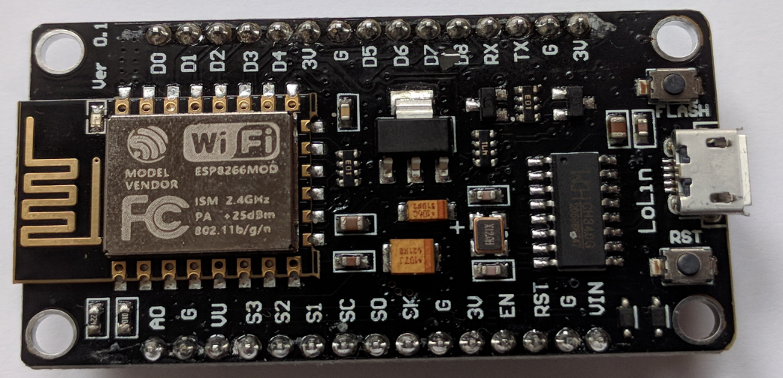

Fig 1.1 ESP 8266 Microcontroller

## 

## 1.3 HISTORY OF ESP 8622

The ESP8266 is a highly popular and versatile Wi-Fi module developed by Espressif Systems, a semiconductor company headquartered in Shanghai, China. It has played a significant role in the proliferation of IoT devices due to its low cost, small form factor, and ease of use. Here's a brief history of the ESP8266:

**1. Introduction (2014):** Espressif Systems introduced the ESP8266 in 2014. Initially, it was primarily intended as a low-cost Wi-Fi module for adding Wi-Fi connectivity to microcontroller-based projects. However, its capabilities and affordability quickly caught the attention of electronics enthusiasts, makers, and developers around the world.

**2. First Generation Modules (2014-2015):** The initial ESP8266 modules were based on the ESP8266EX chip, featuring a 32-bit Tensilica L106 microcontroller running at 80MHz. These modules typically had limited GPIO (General Purpose Input/Output) pins but were capable of establishing Wi-Fi connections and communicating over TCP/IP.

**3. Popularity Surge (2015):** The ESP8266 gained immense popularity in the maker and IoT communities due to its low cost (especially compared to alternative Wi-Fi modules), ease of use, and extensive community support. Makers and developers started using it in various projects ranging from home automation to remote sensing.

**4. ESP8266 SDK and Firmware Updates (2015-2016):** Espressif released SDKs and firmware updates to improve the capabilities and stability of the ESP8266 modules. These updates introduced features such as better Wi-Fi connectivity, improved documentation, and support for additional programming.

**5. ESP8266 Community and Projects (2015-present):** The ESP8266 community grew rapidly, with enthusiasts sharing tutorials, projects, and libraries online. This collaborative ecosystem played a crucial role in expanding the module's applications and capabilities.

**6. Second Generation Modules (2016-present):** Espressif released second-generation ESP8266 modules with improved features such as increased GPIO pins, better power management, and enhanced performance. These newer modules provided developers with more flexibility and options for their projects.

**7. ESP8266 in Commercial Products (2016-present):** Due to its low cost and reliability, the ESP8266 found its way into a wide range of commercial products, including smart home devices, IoT sensors, Wi-Fi-enabled appliances, and more.

**8. Continued Development (2020-present):** Espressif continues to support and develop the ESP8266 platform, releasing periodic updates and improvements to the SDK, firmware, and documentation.

Overall, the ESP8266 has had a profound impact on the maker and IoT communities, democratizing access to Wi-Fi connectivity and enabling countless innovative projects and products. Its legacy continues to influence the development of new IoT solutions and technologies.

## 1.4 ESP 8266 COMPARED WITH OTHER MICROCONTROLLER

Comparing the ESP8266 with other microcontrollers is a bit like comparing apples to oranges because the ESP8266 is primarily a Wi-Fi module while other microcontrollers serve as general-purpose computing devices. However, I'll compare the ESP8266 with some common microcontrollers to highlight their differences:

**1. ESP8266 vs. Arduino Uno:**

The Arduino Uno is a popular microcontroller board based on the ATmega328P microcontroller. It doesn't have built-in Wi-Fi capabilities like the ESP8266. While the Arduino Uno is more versatile and can handle various types of projects, it requires additional hardware (such as Wi-Fi shields) to add Wi-Fi connectivity. The ESP8266, on the other hand, has built-in Wi-Fi capabilities, making it more suitable for IoT projects where Wi-Fi connectivity is essential.

**2. ESP8266 vs. Raspberry Pi:**

The Raspberry Pi is a single-board computer (SBC) with significantly more processing power and features than the ESP8266. Unlike the ESP8266, the Raspberry Pi can run a full operating system (such as Linux) and supports a wide range of programming languages and applications. While the Raspberry Pi can handle more complex tasks and multitasking, it consumes more power and may be overkill for simpler IoT projects that only require Wi-Fi connectivity.

**3. ESP8266 vs. STM32:**

STM32 microcontrollers, based on the ARM Cortex-M architecture, are known for their performance, low power consumption, and rich peripheral set. Unlike the ESP8266, STM32 microcontrollers typically don't have built-in Wi-Fi capabilities. However, they can communicate with external Wi-Fi modules or connect to the internet via Ethernet. STM32 microcontrollers are often chosen for applications requiring real-time processing, precise timing, or low power consumption, while the ESP8266 is favored for its ease of use and Wi-Fi connectivity.

**4. ESP8266 vs. ESP32:**

The ESP32 is the successor to the ESP8266 and offers more features, including Bluetooth, more GPIO pins, and more processing power. While the ESP8266 is cheaper and simpler, the ESP32 provides additional capabilities for more advanced IoT projects. Choosing between the ESP8266 and ESP32 depends on the specific requirements of the project, including cost, power consumption, and required features.

In summary, while the ESP8266 offers convenient built-in Wi-Fi connectivity at a low cost, other microcontrollers provide more processing power, versatility, and features for different types of projects. The choice depends on factors such as project requirements, budget, and desired features.

**1.5 BENEFITS OF ESP 8266**

ESP8266 microcontroller is widely popular in the realm of IoT and embedded systems due to its versatility, low cost, and feature-rich capabilities. Here are some of the key benefits of using the ESP8266 controller:

**1. Built-in Wi-Fi Connectivity:** The ESP8266 comes with built-in Wi-Fi connectivity, which allows devices to connect to the internet and communicate with other devices or servers wirelessly. This feature is essential for IoT applications where remote communication and control are required.

**2. Low Cost:** One of the significant advantages of the ESP8266 is its low cost compared to other microcontrollers with similar capabilities. This makes it an attractive option for hobbyists, makers, and small-scale projects with budget constraints.

**3. Ease of Programming:** The ESP8266 can be programmed using various programming languages and development environments, including Arduino IDE, MicroPython, Lua, and more. Its compatibility with Arduino IDE, in particular, makes it accessible to a broad community of developers and enthusiasts.

**4. Rich Peripheral Support:** Despite its small size and low cost, the ESP8266 offers a rich set of peripherals including GPIO pins, SPI, I2C, UART, ADC, PWM, and more. This allows developers to interface the microcontroller with various sensors, actuators, displays, and other hardware components easily.

**5. Highly Integrated:** The ESP8266 integrates a MCU with Wi-Fi capabilities into a single chip, which reduces the overall hardware footprint and simplifies the design process for IoT devices and embedded systems.

**6. Community Support and Documentation:** The ESP8266 has a large and active community of developers, makers, and enthusiasts who contribute libraries, tutorials, and documentation. This wealth of resources makes it easier for developers to learn, troubleshoot, and innovate with the ESP8266 platform.

**7. Scalability:** While the ESP8266 is suitable for small-scale projects and prototypes, it also offers scalability for larger deployments. Its low cost and compact form factor make it feasible to deploy multiple devices in IoT networks and smart systems.

**8. Firmware Updates:** The ESP8266 supports over-the-air (OTA) firmware updates, allowing devices to receive and install software updates remotely. This feature is crucial for maintaining and improving the functionality of deployed IoT devices without physical access.

**9. Power Efficiency:** The ESP8266 is designed to be power-efficient, making it suitable for battery-powered or energy-constrained applications. It offers various power-saving modes and features to optimize power consumption based on the specific requirements of the application.

Overall, the ESP8266 microcontroller offers a compelling combination of features, affordability, and community support, making it an excellent choice for a wide range of IoT and embedded projects.

# CHAPTER 2

## LITERATURE REVIEW

### 2.1 [IOT Based Crop Protection System against Birds and Wild Animal Attacks](https://www.academia.edu/download/62909409/149166_paper20200411-87185-1gbdyl5.pdf):

### P. Navaneetha, R. Ramiya Dev, S. Vennila, P. Manikandan, Dr. S. Saravanan:

### The main aim of our project is to protect the crops from damage caused by animal as well as divert the animal without any harm. Crops in farms are many times ravaged by local animals like buffaloes, cows, goats, birds etc. This leads to huge losses for the farmers. It is not possible for farmers to barricade entire fields or stay on field 24 hours and guard it. So here we propose automatic crop protection system from animals. Animal detection system is designed to detect the presence of animal and offer a warning. In this project we used PIR and ultrasonic sensors to detect the movement of the animal and send signal to the controller. It diverts the animal by producing sound and signal further, this signal is transmitted to GSM and which gives an alert to farmers and forest department immediately.

### 2.2 [IoT based smart crop-field monitoring and automation irrigation system](https://ieeexplore.ieee.org/abstract/document/8399118/):

### R. Nageswara Rao, B. Sridhar:

Agriculture plays vital role in the development of agricultural country like India. Issues concerning agriculture have been always hindering the development of the country. The only solution to this problem is smart agriculture by modernizing the current traditional methods of agriculture. Hence the proposed method aims at making agriculture smart using automation and IoT technologies. IoT enables various applications crop growth monitoring and selection, irrigation decision support, etc. A Raspberry Pi based automatic irrigation IOT system is proposed to modernization and improves productivity of the crop. main aim of this work to crop development at low quantity water consumption, In order to focus on water available to the plants at the required time, for that purpose most of the farmers waste lot time in the fields. An efficient management of water should be developed and the system circuit complexity to be reduced. The proposed system developed on the information sent from the sensors and estimate the quantity of water needed. Two sensors are used to get the data to the base station the humidity and the temperature of the soil, the humidity, the temperature, and the duration of sunshine per day. The proposed systems based on these values and calculate the water quantity for irrigation is required. The major advantage the system is implementing of Precision Agriculture (PA) with cloud computing, that will optimize the usage of water fertilizers while maximizing the yield of the crops and also will help in analysing the weather conditions of the field.

# 2.3 Community alarm system design based on MCU and GSM:

# Hanshi Wang; Jingili Lu; Liz hen Liu; Wei Song; Zhao Xia Wang:

# In this paper, we use GSM mobile network that is the most reliable and matured in this day to achieve community alarm system. And it will directly convey the alarm news in short message or telephone at manager's mobile phone. The design includes hardware and software parts. Its hardware uses MCU AT89C52 series as the core, and controls three alarm parts, they are infrared monitoring alarm system, alarm displayed on LCD, and GSM module. The system adopted passive infrared sensor to detect, and it turned the traditional network security and anti-theft window into the invisible network, so as to timely handle accidents. When the accident happened in the community, the infrared sensor module sends out the alarm signal to the micro-controller, single chip microcomputer receives the signal through the GSM module to send the message immediately to the manager, and then managers to take immediate measures, the site security alarm and remote alarm can be achieved simultaneously.

### 2.4 [Ultrasonic and infrared sensors performance in a wireless obstacle detection system](https://ieeexplore.ieee.org/abstract/document/6959967/):

### Mustapha, Baharuddin, AladinZayegh, and Razaul K. Begg

### In this project, ultrasonic (US) and infrared (IR) sensors are harnessed to create an obstacle detection system tailored for mobile applications, specifically designed to assist the elderly and individuals with visual impairments. The primary goal is to develop a prototype capable of accurately detecting obstacles in the surrounding environment. Through meticulous calibration and linearization of the sensor circuits, the system achieves impressive levels of accuracy, ranging from 95% to 99%, in distance measurements. This ensures that the system provides reliable feedback regarding the proximity of obstacles, thereby enhancing safety and mobility for users. Moreover, the versatility of the system is underscored by its adeptness in detecting obstacles composed of various materials, including wood, plastic, mirrors, plywood, and concrete. Additionally, it exhibits proficiency in discerning obstacles of different colours, further broadening its applicability across diverse environments and scenarios. One notable aspect of the system's performance is its capability to detect obstacles measuring as small as 5 cm × 5 cm. This sensitivity to relatively diminutive obstacles contributes significantly to its effectiveness in providing timely warnings and facilitating obstacle avoidance.

# CHAPTER 3

## EXISTING SYSTEM

Paper presents a laser security system for animals is an innovative mini project, and science fair endeavors, providing effective protection for pets and livestock. Operating on the principle of LIDAR, it emits a beam of light forming a protective barrier over a designated area. When an animal or object interrupts the beam, an alarm is triggered, alerting the owner or caretaker.

Comprising a laser emitter, detector, and alarm system, the setup is non-invasive and harmless to animals, ensuring ethicality and practicality. Notably, it doesn't rely on any processor, simplifying its design and operation. Its straightforward installation and operation make it accessible for students, while its use of LIDAR technology ensures efficiency and reliability. Furthermore, it offers continuous 24/7 monitoring and protection, providing peace of mind to pet owners and farmers.

In conclusion, the laser security system for animals integrates innovation with simplicity, appealing to students interested in physics, science, and technology. By utilizing LIDAR technology without the need for processors, it offers a cost-effective solution for safeguarding animals while prioritizing their well-being.

# PROBLEM STATEMENT

Farmers are grappling with the relentless challenge of safeguarding their crops round the clock against the incessant threat posed by wild and stray animals. The arduous task demands an unceasing presence in the fields, depriving farmers of much-needed respite and rest. Unable to afford the luxury of uninterrupted sleep or a break from vigilance, they find themselves caught in a perpetual cycle of guarding their livelihoods. This predicament not only imposes physical and mental strain but also jeopardizes the yield upon which their sustenance hinges. As the night falls, the vulnerability of their crops intensifies, compelling farmers to devise makeshift solutions in a desperate bid to deter marauding creatures. Despite their valiant efforts, the nocturnal raiders persist, leaving a trail of devastation in their wake and exacerbating the plight of farmers already burdened by myriad challenges.

# CHAPTER 4

## PROPOSED SYSTEM

A security alarm is a system designed to detect intrusion – unauthorized entry – into a building or area. The word LASER stands for Light Amplification by Stimulated Emission of Radiation. These are available in different types like semiconductor, infrared, Ga As laser diode. This has an energy wavelength of approximately 900 nanometers with a beam divergence of 3 million radians i.e. equal to a beam width small beam width. Security alarms are used in residential, commercial, industrial, and military properties for protection against burglary (theft) or property damage, as well as personal protection against intruders. Car alarms likewise protect vehicles and their contents.

Moreover, some alarm systems serve a single purpose of burglary protection; combination systems provide both fire and intrusion protection. Intrusion alarm systems may also be combined with closed-circuit television surveillance systems to automatically record the activities of intruders, and may interface to access control systems for electrically locked doors. Systems range from small, self-contained noisemakers, to complicated, multi-area systems with computer monitoring and control.

Additionally, this project employs the ESP8266 microcontroller, facilitating the sending of alert messages directly to the farmer's phone. Alongside alert sounds, this system is specifically tailored for agricultural fields, offering protection against wild animals.

### 4.1 CONTRIBUTION OF IoT IN THIS PROJECT

### In this project, IoT plays a crucial role in enhancing the functionality and efficiency of the security system. The integration of IoT allows for remote monitoring and control of the laser security system, providing real-time updates and alerts to the farmer's smartphone or any other connected device.

### By incorporating IoT technology, the ESP8266 microcontroller can communicate with the farmer's phone via the internet, enabling seamless transmission of alert messages in case of any intrusion detected by the system. This enables the farmer to receive instant notifications regardless of their location, empowering them to take immediate action to safeguard their agricultural field from potential threats posed by wild animals.

### Furthermore, IoT facilitates data collection and analysis, allowing farmers to gather valuable insights into patterns of animal activity and potential vulnerabilities in their security measures. This information can then be utilized to optimize the effectiveness of the laser security system and make informed decisions regarding resource allocation and risk mitigation strategies.

### Overall, the integration of IoT elevates the laser security system for agricultural fields to a new level of sophistication and effectiveness, enabling proactive protection against intruders while providing farmers with greater control and peace of mind.

## 4.2 METHODOLOGY

The methodology for implementing the laser security system for agricultural fields involves several key steps:

1. **Project Planning and Requirements Analysis:** Begin by defining the objectives of the project, including the desired range of the security system, types of alerts required, and integration with IoT technology. Identify the components needed for the system, such as laser emitters, detectors, microcontrollers, and communication modules.
2. **Component Acquisition:** Procure the necessary components based on the project requirements. Ensure compatibility between the components, such as selecting a laser emitter with appropriate specifications for the desired range and beam width.
3. **System Design:** Design the layout of the security system, including the placement of laser emitters and detectors to create a protective barrier around the agricultural field. Determine the communication protocol and interface for connecting the microcontroller to the IoT platform and farmer's smartphone.
4. **Hardware Assembly:** Assemble the hardware components according to the system design. Mount the laser emitters and detectors at strategic locations around the perimeter of the field, ensuring proper alignment and coverage.
5. **Programming:** Develop the firmware for the microcontroller, such as the ESP8266, to control the laser emitters, detect interruptions in the laser beams, and trigger alerts. Implement communication protocols for transmitting alert messages to the IoT platform and farmer's smartphone.
6. **Integration with IoT:** Configure the IoT platform to receive data from the microcontroller and send alerts to the farmer's smartphone. Establish secure communication channels to ensure data privacy and integrity.
7. **Testing and Calibration:** Conduct through testing of the security system to verify its functionality and reliability. Calibrate the system as needed to optimize performance and minimize false alarms.
8. **Deployment:** Install the security system in the agricultural field, ensuring proper alignment and configuration. Train the farmer on how to use the system and interpret alert messages received on their smartphone.
9. **Monitoring and Maintenance:** Regularly monitor the security system for any issues or malfunctions. Perform routine maintenance tasks, such as cleaning the laser emitters and detectors, to ensure continued operation.

## 

## 4.3 BLOCK DIAGRAM

Power Supply

6

LED

ESP 8266

BUZZER

LDR

Farmer’s Internet Connection

Farmer’s Smartphone

## 4.4 WORKING

Laser security systems used to be difficult to install and rarely available to anyone other than the super-rich. Now, there are dozens of different security systems on the market that utilize lasers and can effectively protect everything from small apartments and businesses to large areas of property. Most home laser security systems consist of two parts: a basic alarm unit and an infrared motion detector. Laser security systems of the past used to rely on connections wired to a keypad, requiring the customer to use special codes to arm and disarm the system. Since the majority of laser security systems are now wireless, the units can be turned on or off with a wireless remote or, in some models, by touch tone phone from anywhere in the world.

Here, Laser security system is a simple circuit using ESP8266. This circuit is triggered when the Laser beam falls on the LDR interrupts, which sounds the buzzer connected to it. This can be used to protect your valuable items, money, room etc. your valuable items, money, room etc.

This can also be used to protect more than one objects by suitably arranging mirrors.  One possible arrangement is shown below.

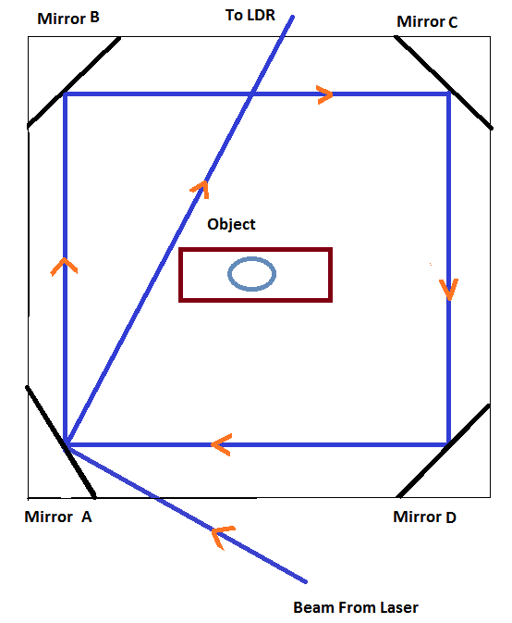

Figure 4.1 Mirror arrangements of Laser security system

**4.5 OBJECTIVES**

The objective of animal avoidance in agricultural farms is to prevent damage to crops, livestock, and property caused by wild or stray animals. The goal is to protect the farmer's livelihood while also promoting coexistence with wildlife and maintaining biodiversity.

## 4.6 WORKING OF ESP 8266

The ESP8266 is a versatile and widely used Wi-Fi module that can function as a standalone microcontroller. Here's an overview of how the ESP8266 works:

**1. Microcontroller:** The ESP8266 integrates a powerful 32-bit Tensilica MCU capable of running at speeds up to 80MHz. This MCU handles tasks such as reading sensor data, controlling actuators, and managing communication protocols.

**2. Wi-Fi Connectivity:** One of the key features of the ESP8266 is its built-in Wi-Fi connectivity. It can connect to Wi-Fi networks, either as a client to access the internet or as an access point to create its own network. This capability allows the ESP8266 to communicate with other devices and services over the internet.

**3. GPIO Pins:** The ESP8266 provides a number of GPIO pins that can be configured as digital input/output or analog input. These pins can be used to interface with sensors, actuators, and other electronic components.

**4. Programming:** The ESP8266 can be programmed using the Arduino IDE or other development environments like MicroPython or Lua. Developers write code to control the ESP8266's behavior, including reading sensor data, processing information, and executing tasks based on predefined conditions.

**5. Communication Protocols:** In addition to Wi-Fi, the ESP8266 supports other communication protocols such as Serial Peripheral Interface (SPI), Inter-Integrated Circuit (I2C), and Universal Asynchronous Receiver-Transmitter (UART). These protocols allow the ESP8266 to communicate with a wide range of peripherals and devices.

**6. Power Management:** The ESP8266 includes power management features to optimize energy consumption. It can operate in low-power modes to conserve battery life in battery-powered applications.

Overall, the ESP8266 is a versatile and cost-effective solution for adding Wi-Fi connectivity and advanced functionality to a wide range of IoT projects. Its combination of processing power, connectivity options, and GPIO pins make it suitable for various applications, from home automation and smart devices to industrial monitoring and control systems.

## 

## 4.7 ARCHITECTURE

The architecture of the Animal Avoidance Mechanism System (AAMS) utilizing the ESP8266 microcontroller can be structured as follows:

**1. Hardware Components:**

**ESP8266 Microcontroller:** The core component responsible for controlling the system's operation, interfacing with sensors, and managing communication.

**Sensors:** LDR sensors for detecting changes in ambient light caused by wildlife intrusion.

**Laser Modules:** Emit laser beams across the field to create a barrier and trigger visual alerts upon interruption.

**Buzzer or Speaker:** Produces audible alarms or deterrent sounds to scare away animals.

**Power Supply:** Provides the necessary power to the system components.

**2. Software Components:**

**Firmware:** Code written for the ESP8266 microcontroller to handle sensor data processing, alert triggering, and communication.

**Wi-Fi Module:** Software libraries for establishing Wi-Fi connectivity and sending SMS notifications over the internet.

**Sensor Interface:** Code to interface with the LDR sensors to detect wildlife intrusion.

**Alert Control:** Logic for controlling the activation of laser modules, buzzer, or speaker based on sensor inputs.

**Communication Module:** Code to handle Wi-Fi communication and send SMS notifications to the farmer's smartphone.

**3. System Architecture:**

The ESP8266 microcontroller serves as the central processing unit, coordinating the operation of the hardware components. Sensors continuously monitor ambient light levels to detect wildlife intrusion. Upon detection, the ESP8266 triggers visual and auditory alerts to deter animals and sends SMS notifications to the farmer's smartphone. Wi-Fi connectivity allows the ESP8266 to communicate with external services or platforms for remote monitoring and control. Power management ensures efficient operation and conservation of energy resources.

**4.** **Integration and Interfacing:**

Hardware components are interconnected and interfaced with the ESP8266 microcontroller using appropriate electrical connections (e.g., GPIO pins). Software components are integrated into the firmware running on the ESP8266, enabling seamless interaction and functionality.

**4.8 COMPONENTS:**

**4.8.1 Transistor-BC548**:

The BC548 is a general purpose [NPN](http://transistor) [bipolar junction transistor](http://transistor) found commonly in European electronic equipment and present-day designs in Australian and British electronics magazines where a commonly-available low-cost NPN transistor is required. It is a part of a family of NPN and PNP [epitaxial](http://en.wikipedia.org/wiki/Epitaxy) silicon transistors that include higher-quality variants, originating in 1966 when [Philips](http://en.wikipedia.org/wiki/Philips) introduced the metal-cased [BC108 family of transistors](http://family) which became the most used transistors in Australiaand taken up by many European manufacturers.

The BC546 and BC547 are essentially the same as the BC548 but selected with higher [breakdown voltages](http://voltage) while the BC549 is low noise version, and the BC550 both high-voltage and low-noise. The BC556 to BC560 are the PNP counterparts of the BC546 to BC550, respectively.

The BC548 is low cost and is available in most European Union and many other countries. It is often the first type of bipolar transistor hobbyists encounter, and is often featured in designs in hobby electronics magazines where a general-purpose transistor is required.

The part number is assigned by [Pro Electron](http://electron), which allows many manufacturers to offer electrically and physically interchangeable parts under one identification. As viewed in the image to the right, and going from left to right, lead 1 (left in diagram) is the collector, lead 2 is the base, and lead 3 is the emitter. Note that not all transistors with TO-92 cases follow this arrangement.

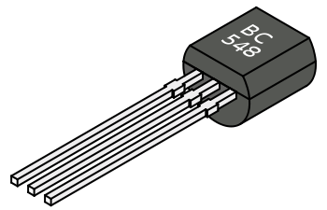

Figure:4.2 Diagram of transistor BC548

**4.8.2 Light Dependent Resistor (or) Photo resistor:**

A photoresistor or light-dependent resistor or photocell is a light-controlled variable [resistor](http://en.wikipedia.org/wiki/Resistor). The [resistance](http://resistance) of a photoresistor decreases with increasing incident light intensity; in other words, it exhibits [photoconductivity](http://en.wikipedia.org/wiki/Photoconductivity). A photoresistor can be applied in light-sensitive detector circuits, and light- and dark-activated switching circuits.

A photoresistor is made of a high resistance [semiconductor](http://en.wikipedia.org/wiki/Semiconductor). In the dark, a photoresistor can have a resistance as high as a few megohms (MΩ), while in the light, a photoresistor can have a resistance as low as a few hundred ohms. If incident light on a photoresistor exceeds a certain [frequency](http://en.wikipedia.org/wiki/Frequency), [photons](http://en.wikipedia.org/wiki/Photon) absorbed by the semiconductor give bound [electrons](http://en.wikipedia.org/wiki/Electron) enough energy to jump into the [conduction band](http://band). The resulting free electrons (and their [hole](http://hole) partners) conduct electricity, thereby lowering [resistance](http://resistance). The resistance range and sensitivity of a photoresistor can substantially differ among dissimilar devices. Moreover, unique photoresistors may react substantially differently to photons within certain wavelength bands.

A photoelectric device can be either intrinsic or extrinsic. An intrinsic semiconductor has its own [charge carriers](http://carrier) and is not an efficient semiconductor, for example, silicon. In intrinsic devices the only available electrons are in the [valence band](http://band), and hence the photon must have enough energy to excite the electron across the entire [bandgap](http://en.wikipedia.org/wiki/Bandgap). Extrinsic devices have impurities, also called [dopants](http://en.wikipedia.org/wiki/Dopants), added whose ground state energy is closer to the conduction band; since the electrons do not have as far to jump, lower energy photons (that is, longer wavelengths and lower frequencies) are sufficient to trigger the device. If a sample of silicon has some of its atoms replaced by phosphorus atoms (impurities), there will be extra electrons available for conduction. This is an example of an extrinsic semiconductor.

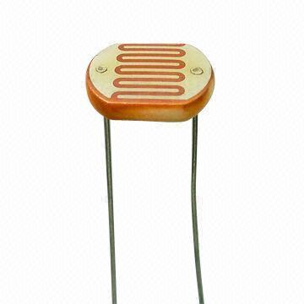

Figure:4.3 Diagram of light dependent resistor

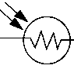

Figure:4.4 Symbol of light dependent resistor

**Design procedure:**

Photoresistors are less light-sensitive devices than [photodiodes](http://en.wikipedia.org/wiki/Photodiode) or [phototransistors](http://en.wikipedia.org/wiki/Phototransistor): the two latter components are true [semiconductor devices](http://device), while a photoresistor is a passive component and does not have a PN-junction. The photo resistivity of any photoresistor may vary widely depending on ambient temperature, making them unsuitable for applications.

Photoresistors also exhibit a certain degree of latency between exposure to light and the subsequent decrease in resistance, usually around 10 milliseconds. The lag time when going from lit to dark environments is even greater, often as long as one second. This property makes them unsuitable for sensing rapidly flashing lights, but is sometimes used to smooth the response of audio signal compression.

**Applications:**

Photoresistors come in many types. Inexpensive [cadmium sulphide](http://sulphide) cells can be found in many consumer items such as camera light meters, street lights, clock radios, [alarm devices](http://devices), [night lights](http://light), outdoor clocks, solar street lamps and solar road studs, etc.

They are also used in some [dynamic compressors](http://compression) together with a small [incandescent](http://lamp) or [neon](http://en.wikipedia.org/wiki/Neon) [lamp](http://lamp), or [light-emitting diode](http://diode) to control gain reduction. A common usage of this application can be found in many [guitar amplifiers](http://amplifiers) that incorporate an onboard tremolo effect, as the oscillating light patterns control the level of signal running through the amp circuit. The use of Cd S and [Cd Se](http://selenide) photoresistors is severely restricted in Europe due to the [RoHS](http://directive) ban on cadmium.

[Lead sulphide](http://sulphide) (Pb S) and [indium antimonide](http://antimonide) (In Sb) LDRs are used for the mid-infrared spectral region. [Ge](http://en.wikipedia.org/wiki/Germanium): [Cu](http://en.wikipedia.org/wiki/Copper) photoconductors are among the best far-[infrared](http://en.wikipedia.org/wiki/Infrared) detectors available, and are used for [infrared astronomy](http://astronomy) and [infrared spectroscopy](http://spectroscopy).

**Light Dependent Resistor, Photoresistor, or Photocell:**

The light dependent resistor, LDR, is known by many names including the photoresistor, photo resistor, photoconductor, photoconductive cell, or simply the photocell. It is probably the term photocell that is most widely used in data and instruction sheets for domestic equipment.

The photoresistor, or light dependent resistor, LDR, finds many uses as a low cost photo sensitive element and was used for many years in photographic light meters as well as in other applications such as flame, smoke and burglar detectors, card readers and lighting controls for street lamps. Often within the literature the photoresistor is called the photocell as a more generic term.

**Photoresistor discovery:**

Photoresistors, or light dependent resistors have been in use for very many years. Photoresistors have been seen in early forms since the nineteenth century when photoconductivity in selenium was discovered by Smith in 1873. Since then many variants of photoconductive devices have been made.

Much useful work was conducted by T. W. Case in 1920 when he published a paper entitled "Thalofide Cell - a new photo-electric cell". Other substances including Pb S, Pb Se and Pb Te were studied in the 1930s and 1940s, and then in 1952, Rollin and Simmons developed their photoconductors using silicon and germanium.

**Light dependent resistor symbol:**

The circuit symbol used for the light dependent resistor or photoresistor combines its resistor action while indicating that it is sensitive to light. The basic light dependent resistor symbol has the rectangle used to indicate its resistor action, and then has two incoming arrows - the same as those used for photodiodes.

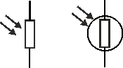  
 Figure:4.5 Light dependent resistor symbol used in circuit diagrams

For most applications, the light dependent resistor symbol used will be that with the resistor with arrows, but in some instances, those drawing circuit diagrams prefer to encase the resistor in a circle. The more commonly used photoresistor symbol is the resistor without the circle around it.

**Photoresistor mechanism:**

A photoresistor or photocell is a component that uses a photoconductor between two contacts. When this is exposed to light a change in resistance is noted.

Photoconductivity - the mechanism behind the photoresistor - results from the generation of mobile carriers when photons are absorbed by the semiconductor material used for the photoconductor. While the different types of material used for light dependent resistors are semiconductors, when used as a photo-resistor, they are used only as a resistive element and there are no PN junctions. Accordingly, the device is purely passive.

There are two types of photoconductors and hence photoresistor:

* **Intrinsic photoresistor:**   This type of photoresistor uses a photoconductive material that involves excitation of charge carriers from the valence bands to the conduction band.
* **Extrinsic photoresistor:**   This type of photoresistor uses a photoconductive material that involves excitation of charge carriers between an impurity and the valence band or conduction.

**Basic photo resistor structure:**

Although there are many ways in which light dependent resistors, or photo resistors can be manufactured, there are naturally a few more common methods that are seen. Essentially the photo resistor or photocell consists of a resistive material sensitive to light that is exposed to light. The photo resistive element comprises section of the material with contacts at either end. A typical structure for a light dependent or photo resistor uses an active semiconductor layer that is deposited on an insulating substrate. The semiconductor is normally lightly doped to enable it to have the required level of conductivity. Contacts are then placed either side of the exposed area.

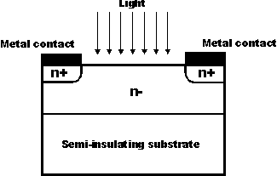  
 Figure:4.6 One form of photo resistor structure

Within the basic photo resistor or photocell structure, the resistance of the material itself is a key issue. To ensure the resistance changes resulting from the light dominate, contact resistance is minimized. To achieve this, the area around the contacts is normally heavily doped to reduce the resistance in this region.

In many instances the area between the contacts is in the form of a zig zag, or inter digital pattern. This maximizes the exposed area and by keeping the distance between the contacts small it reduces the spurious resistance levels and enhances the gain.

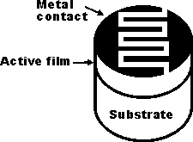  
 Figure:4.7 Photoresistor or photocell with inter digital contact pattern

**4.8.3 Resistors:**

A resistor is a passive two-terminal [electrical component](http://component) that implements [electrical resistance](http://resistance) as a circuit element. Resistors act to reduce current flow, and, at the same time, act to lower voltage levels within circuits. In electronic circuits resistors are used to limit current flow, to adjust signal levels, [bias](http://en.wikipedia.org/wiki/Biasing) active elements, terminate [transmission lines](http://line) among other uses. High-power resistors that can dissipate many [watts](http://en.wikipedia.org/wiki/Watt) of electrical power as heat may be used as part of motor controls, in power distribution systems, or as test loads for [generators](http://generator). Fixed resistors have resistances that only change slightly with temperature, time or operating voltage. Variable resistors can be used to adjust circuit elements (such as a volume control or a lamp dimmer), or as sensing devices for heat, light, humidity, force, or chemical activity.

Resistors are common elements of [electrical networks](http://network) and [electronic circuits](http://circuit) and are ubiquitous in [electronic equipment](http://en.wikipedia.org/wiki/Electronics). Practical resistors as discrete components can be composed of various compounds and forms. Resistors are also implemented within [integrated circuits](http://circuits).

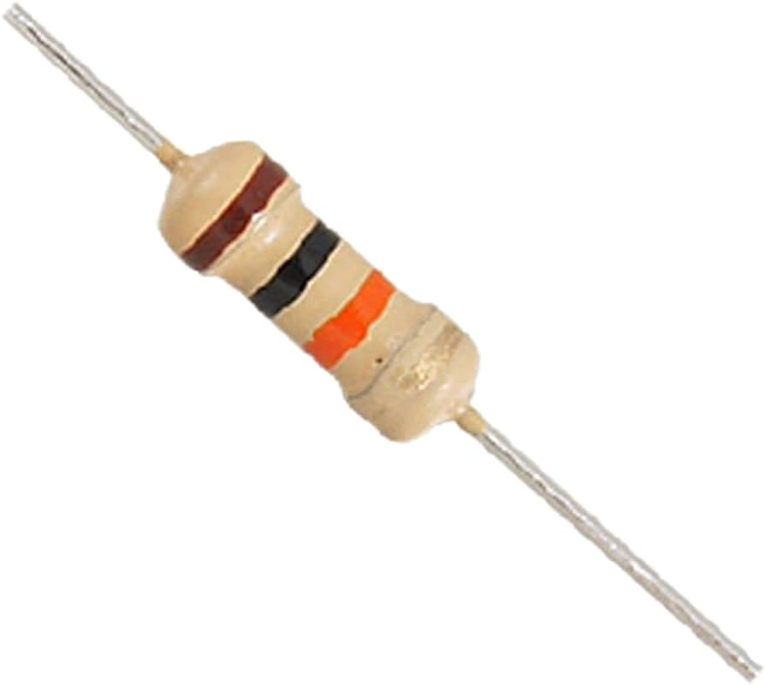

Figure:4.8 Resistor(10k)

**Power dissipation:**

At any instant of time, the power P (watts) consumed by a resistor of resistance R (ohms) is calculated as: P diss=2I/R where V (volts) is the voltage across the resistor and I (amps) is the [current](http://en.wikipedia.org/wiki/Ampere) flowing through it. Using [Ohm's law](http://law), the two other forms can be derived. This power is converted into heat which must be dissipated by the resistor's package before its temperature rises excessively.

Resistors are rated according to their maximum power dissipation. Most discrete resistors in solid-state electronic systems absorb much less than a watt of electrical power and require no attention to their power rating. Such resistors in their discrete form, including most of the packages detailed below, are typically rated as 1/10, 1/8, or 1/4 w

Non-ideal properties:

Practical resistors have a series [inductance](http://en.wikipedia.org/wiki/Inductance) and a small parallel [capacitance](http://en.wikipedia.org/wiki/Capacitance); these specifications can be important in high-frequency applications. In a [low-noise amplifier](http://amplifier) or [pre-amp](http://en.wikipedia.org/wiki/Pre-amp), the noise characteristics of a resistor may be an issue. The [temperature coefficient](http://coefficient) of the resistance may also be of concern in some precision applications.

**4.8.4 Buzzer:**

A buzzer or beeper is an [audio](http://en.wikipedia.org/wiki/Sound) signaling device, which may be  [mechanical](http://en.wikipedia.org/wiki/Machine), [electromechanical](http://en.wikipedia.org/wiki/Electromechanics), or [piezoelectric](http://en.wikipedia.org/wiki/Piezoelectricity). Typical uses of buzzers and beepers include [alarm devices](http://devices), [timers](http://en.wikipedia.org/wiki/Timer) and confirmation of user input such as a mouse click or keystroke. Early devices were based on an electromechanical system identical to an [electric bell](http://bell) without the metal gong. Similarly, a [relay](http://en.wikipedia.org/wiki/Relay) may be connected to interrupt its own actuating [current](http://current), causing the [contacts](http://en.wikipedia.org/wiki/Switch) to buzz. Often these units were anchored to a wall or ceiling to use it as a sounding board. The word "buzzer" comes from the rasping noise that electromechanical buzzers made. piezoelectric element may be driven by an [oscillating](http://en.wikipedia.org/wiki/Oscillation) electronic circuit or other [audio signal](http://signal) source, driven with a [piezoelectric audio amplifier](http://amplifier). Sounds commonly used to indicate that a button has been pressed are a click, a ring or a beep.

Uses:

* [Annunciator panels](http://panel)
* Electronic [metronomes](http://en.wikipedia.org/wiki/Metronome)
* [Game show](http://show) [lock-out device](http://device)
* [Sporting](http://en.wikipedia.org/wiki/Sport) events such as [basketball](http://en.wikipedia.org/wiki/Basketball) games
* 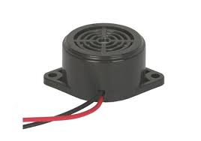Electrical [alarms](http://en.wikipedia.org/wiki/Alarms)

Figure:4.9 Diagram of buzzer

## ADVANTAGES

The Animal Avoidance Mechanism System utilizing the ESP8266 microcontroller offers several advantages:

1. **Effective Wildlife Deterrence:** The AAMS swiftly detects and deters wildlife intrusion using a combination of sensors, laser alerts, sound, and SMS notifications. This proactive approach helps prevent crop damage and minimize agricultural losses.
2. **Non-lethal and Humane:** Unlike traditional methods of wildlife control, such as traps or poisons, the AAMS employs non-lethal deterrent mechanisms. This promotes humane wildlife management practices and reduces harm to animals.
3. **Real-time Alerts:** The system provides real-time alerts to the farmer's smartphone via SMS notifications, enabling timely response to wildlife intrusion. This allows farmers to take immediate action to protect their crops and property.
4. **Customizable and Scalable:** The AAMS can be customized and scaled to suit the specific needs of different agricultural settings. Farmers can adjust sensor sensitivity, alert thresholds, and deployment locations to optimize system performance.
5. **Cost-effective:** Utilizing the ESP8266 microcontroller and off-the-shelf components makes the AAMS a cost-effective solution compared to traditional wildlife control methods. It offers a high return on investment by reducing crop losses and minimizing the need for expensive repairs or replacements.
6. **Promotes Sustainable Agriculture:** By minimizing crop damage and losses, the AAMS contributes to sustainable agriculture practices. It helps farmers maintain productivity while reducing the environmental impact of wildlife management activities.
7. **Enhances Safety and Security:** The AAMS enhances the safety and security of agricultural fields by deterring potential threats from wildlife intruders. This promotes a safer working environment for farmers and reduces the risk of confrontations with dangerous animals.
8. **Encourages Coexistence:** By providing a non-lethal and proactive approach to wildlife management, the AAMS fosters harmonious coexistence between humans and wildlife. It supports biodiversity conservation efforts while addressing the challenges of agricultural production.

## DISADVANTAGES

While the AAMS utilizing the ESP8266 microcontroller offers several advantages, it also has some potential disadvantages:

1. **Dependency on Power Supply:** The AAMS relies on a continuous power supply to operate effectively. Any disruption in power could render the system inactive, leaving the agricultural field vulnerable to wildlife intrusion.
2. **Limited Range:** The effectiveness of the AAMS may be limited by the range of its sensors and alert mechanisms. Depending on the terrain and size of the agricultural field, there may be areas where the system's coverage is inadequate.
3. **Maintenance and Calibration:** The AAMS requires regular maintenance to ensure proper functioning of its components, including sensor calibration, battery replacement (if applicable), and software updates. Failure to maintain the system could lead to decreased reliability and effectiveness over time.
4. **Cost of Implementation:** While the AAMS offers a cost-effective solution compared to traditional wildlife control methods, there are still costs associated with purchasing and installing the necessary hardware components, as well as ongoing maintenance and monitoring expenses.

# CHAPTER 5

## RESULT

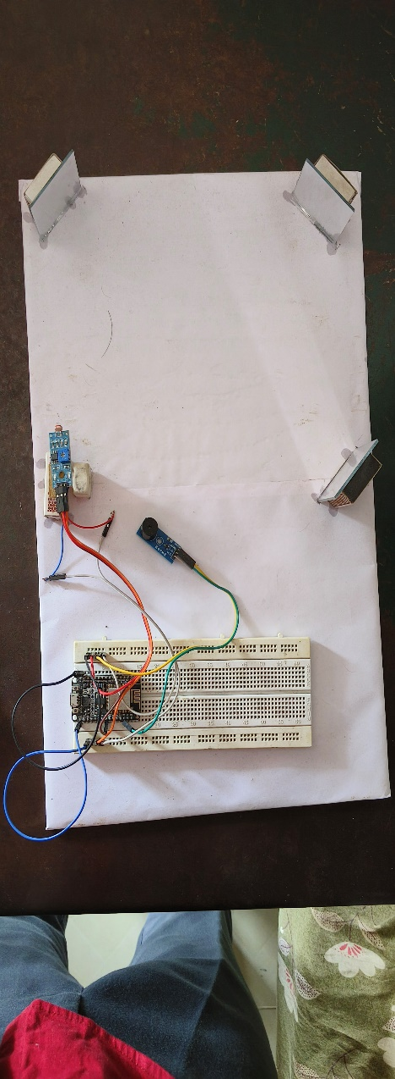The results and discussion of the Animal Avoidance Mechanism System project focus on evaluating the system's performance, discussing its effectiveness in deterring wildlife intrusion, and exploring potential implications for agricultural practices and biodiversity conservation. Through prioritizing environmental considerations, our team has successfully developed a prototype which can avoid the entry of animal system that integrates Laser and LDR sensors, tailored specifically for mobile applications aimed at aiding the elderly and individuals with visual impairments. Furthermore, the system's adeptness in detecting obstacles composed of diverse materials and colors underscores its versatility, allowing for seamless navigation across varied environments without compromising accuracy. With a minimum detection threshold of 5 cm × 5 cm, the prototype demonstrates sensitivity to even the smallest obstacles, further enhancing its utility in real-world scenarios.

# CHAPTETR 6

## CONCLUSION

In conclusion, the AAMS represents a significant advancement in addressing the pressing issue of wildlife intrusion and crop damage in agricultural fields. By combining LDR sensors, laser alerts, sound, and SMS notifications, the AAMS provides a comprehensive and effective solution for mitigating losses due to animal activities.

This integrated system not only detects animals swiftly but also deters them promptly, thereby minimizing agricultural losses and promoting harmonious human-wildlife relations. Furthermore, the AAMS's proactive intervention capabilities enable farmers to take timely action, ultimately leading to more sustainable agriculture practices and better conservation outcomes for biodiversity.

The design and implementation of the AAMS signify a transformative approach to wildlife management in agricultural contexts, offering improved visibility, reaction time, and overall effectiveness. As such, its adoption holds great promise for enhancing agricultural productivity while simultaneously safeguarding natural ecosystems. Overall, the AAMS represents a significant step forward in achieving a balance between agricultural needs and environmental conservation efforts.

# ANNEXURE

## PROGRAMMING

## #include <ESP8266WiFi.h>

## #include <WiFiClientSecure.h>

## #include <UniversalTelegramBot.h>

## #include <ArduinoJson.h>

## const char* ssid = "";

## const char* password = "";

## #define BOTtoken "*"

## #define CHAT_ID ""

## #define LED D4

## #define Buzzer D3

## #define LReceiver D5

## #define Laser D6

## X509List cert(TELEGRAM_CERTIFICATE_ROOT);

## WiFiClientSecure client;

## UniversalTelegramBot bot(BOTtoken, client);

## void setup() {

## Serial.begin(115200);

## configTime(0, 0, "pool.ntp.org");// get UTC time via NTP

## client.setTrustAnchors(&cert); // Add root certificate for api.telegram.org

## pinMode(LReceiver, INPUT);

## pinMode(LED, OUTPUT);

## pinMode(Laser, OUTPUT);

## pinMode(Buzzer, OUTPUT);

## digitalWrite(Laser, HIGH);

## WiFi.mode(WIFI_STA);

## WiFi.begin(ssid, password);

## while (WiFi.status() != WL_CONNECTED) {

## Serial.print(".");

## delay(500);

## }

## Serial.print("\nWiFi connected. IP address: ");

## Serial.println(WiFi.localIP());

## bot.sendMessage(CHAT_ID, "System is Ready", "");

## delay(1000);

## }

## void loop() {

## bool value = digitalRead(LReceiver);

## Serial.println(value);

## if (value == 1) {

## digitalWrite(LED, HIGH);

## digitalWrite(Buzzer, HIGH);

## bot.sendMessage(CHAT_ID, "Warning!", "");

## } else if (value == 0) {

## digitalWrite(LED, LOW);

## digitalWrite(Buzzer, LOW);

## }

## }

**REFERENCE**

[1] P. Navaneetha, R. Ramaiya Devi, S. Vennila, P. Manikandan, Dr. S. Saravanan, “Crop protection against Wild animal’s attacks”. Year 2020.

[2] Atchaya. V, Kowsalya. V, Dhivyabharathi. K. P, Arunkumar. M, “Implementation of crop protection system against wild animal attack”. Year 2019.

[3] R. Nageswara Rao, B. Sridhar: “A Survey on an Efficient IOT Based Smart crop field monitoring and automation irrigation system” Year 2018.

### [4] Mustapha, Baharuddin, AladinZayegh, and Razaul K. Begg: “[Ultrasonic and infrared sensors performance in a wireless obstacle detection system](https://ieeexplore.ieee.org/abstract/document/6959967/)” Year 2017.

# [5] Hanshi Wang; Jingili Lu; Liz hen Liu; Wei Song; Zhao Xia Wang: “Community alarm system design based on MCU and GSM” Year 2015.

# [6]. M. Sathishkumar1, S. Rajini “Smart Surveillance System Using PIR Sensor Network and GSM” Year 2015.

# [7]. Sivagamasundari, S. Janani, “Home surveillance system based on MCU and GSM”, Year 2014.

# [8]. Ms. Sneha Nahatkar, Prof. Avinash Gaur, Prof. Tareek M. Pattewa “Design of a Home Embedded Surveillance System with Pyroelectric Infrared Sensor & Ultra-Low Alert Power” Year 2012.

# [9]. Padmashree S. Dhake, Sumedha S. Borde, “Embedded Surveillance System Using PIR Sensor”, Year2014